1. This mega menu is always popping up, even when the mouse isn't at the menu


2. Developed: This is the home page, not the “why mcgeorge” page

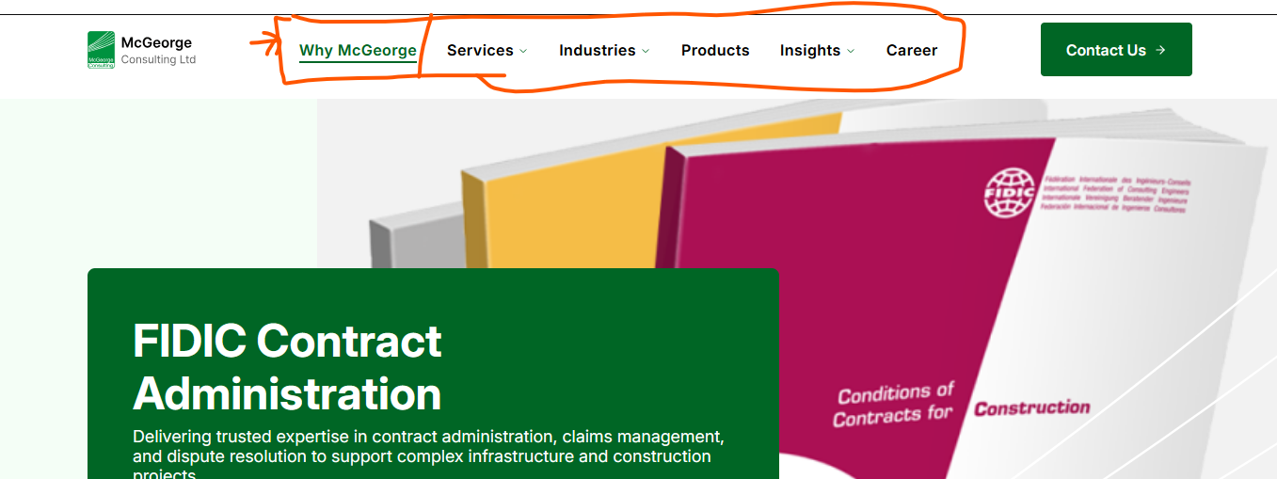

Design:


3. Developed: Check the UI Layout for the slider bar, its not paces over the image beside it. Check figma for the gradient values, the end values of the gradient is at 0%.

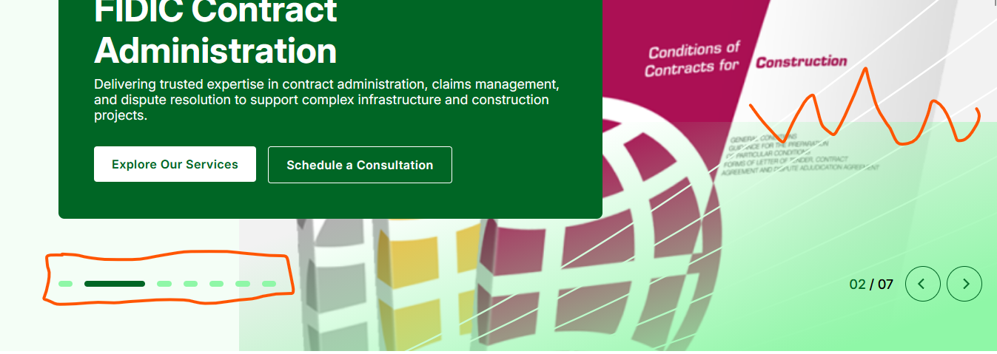

Design:


I’m I’m I’m I’m da

4. Developed: The slider next icons didn't follow the margin to the right.
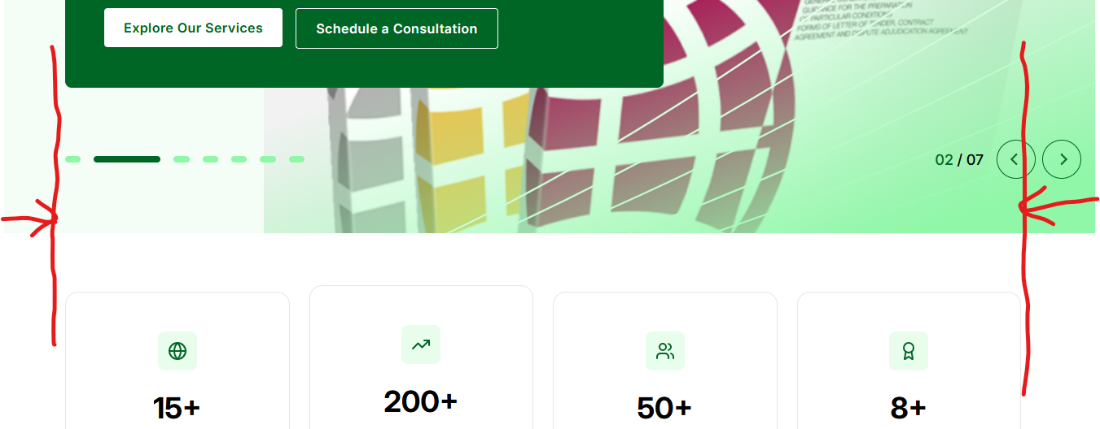

Design:
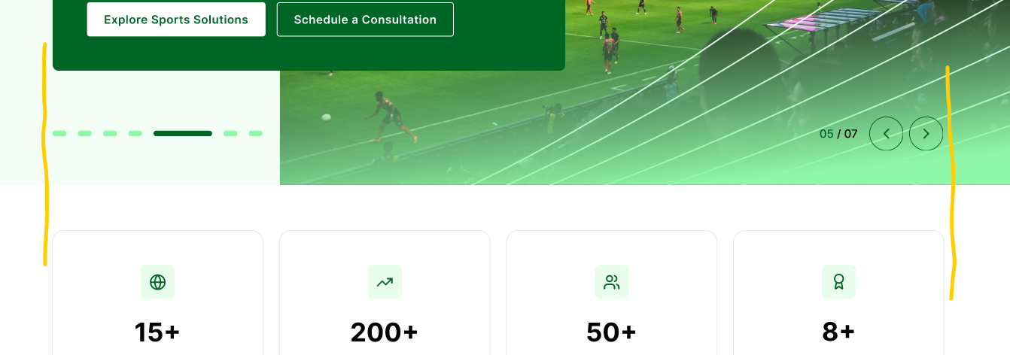

5. Developed: The right DIV image is missing, also check Figma for the updated content.


Design:


6. Developed: Check Figma for the updated content.


Design:
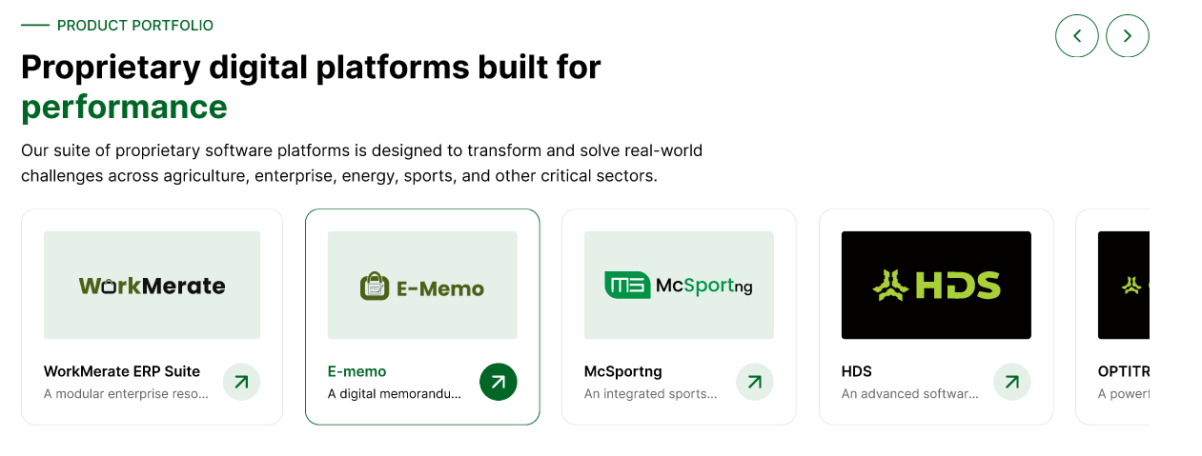

7. Developed: Check Figma for the updated content.
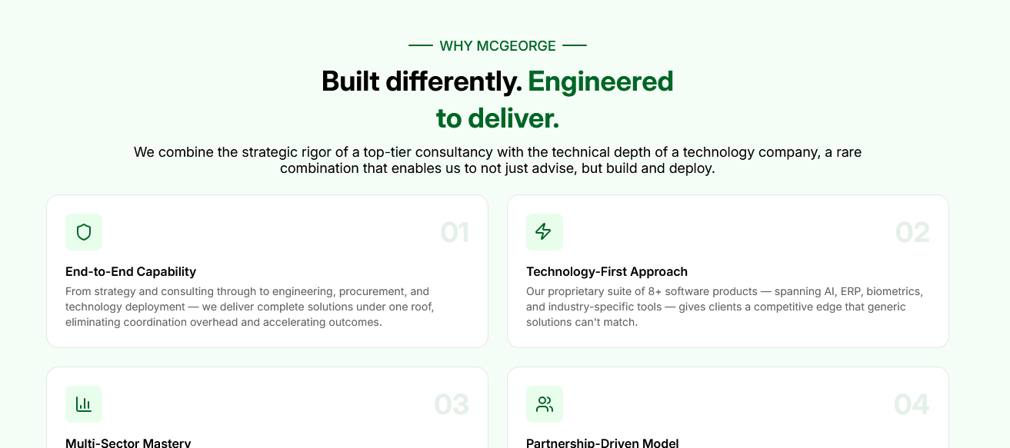

Design:
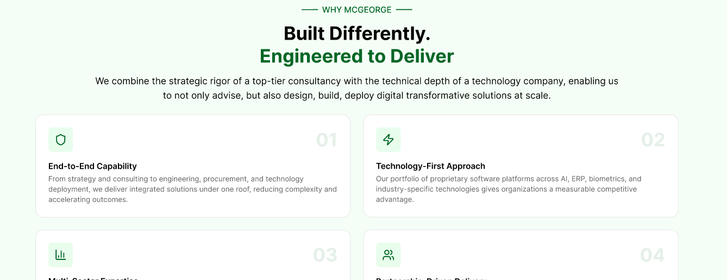
8. Developed: Check Figma for the updated layout.


.

Design:


9. Developed: Check Figma for the updated section.

Design:

10. Developed: Check Figma for the updated content.
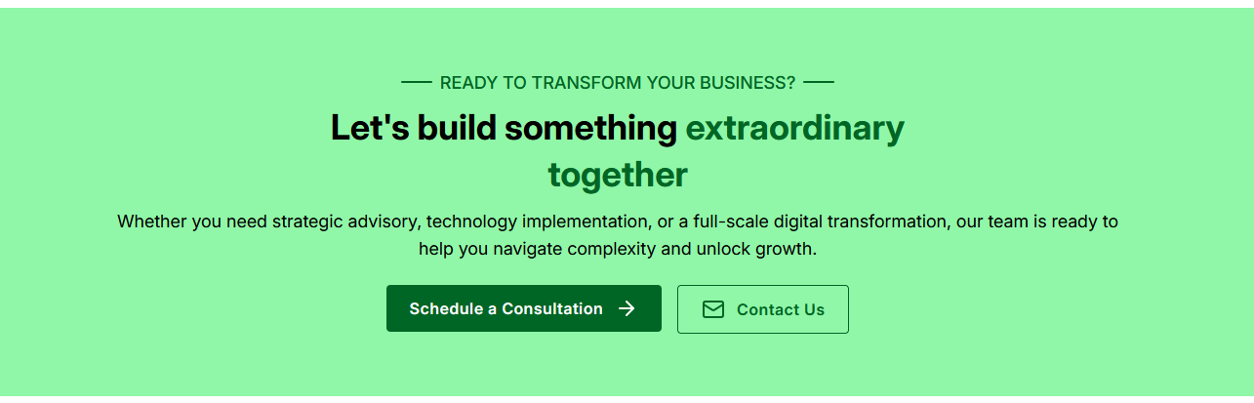

Design:
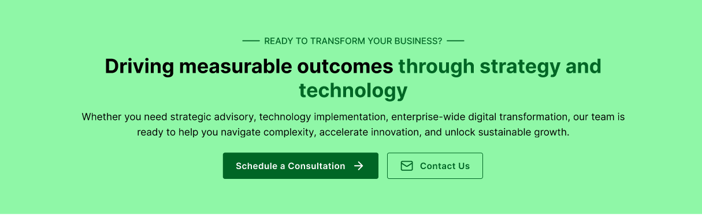
11. Developed: Check Figma for the updated content. Also the email is supposed to be “support@mcgeorge.com” not workmerate.

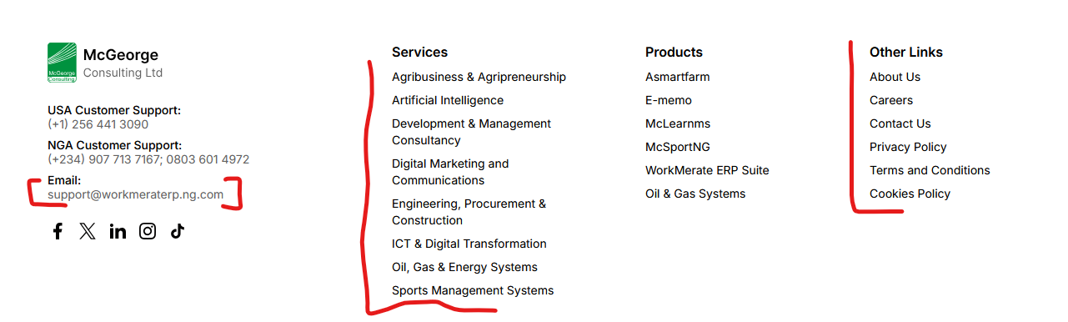

Design:
